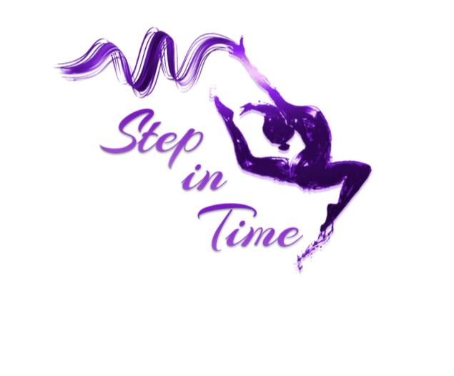
Terms and Conditions

1. All students of Step in Time School of Performing Arts (SiT) must agree to the Terms & Conditions .
2. SiT offers dance classes following the ISTD syllabus, in ballet, tap & modern determined by each student’s ability. Classes in Musical Theatre,Contemporary, Freestyle and Acro dance are also available. SiT reserve the right to cancel any class.
3. Every effort will be made by the school to adhere to the latest time table. However, there may be instances where changes will be made, for example, in the run up to examinations or shows.
4. SiT will aim to provide “face to face” classes as set out in the latest timetable. If for any reason this is not possible, SiT will provide alternative classes:
- 1) On- line classes via Zoom or similar medium
- 2) Temporary, alternative “face to face” classes, possibly on a different day, time, and venue to that timetabled.
A A refund of class fees will not be given where an alternative class is provided.
5. Students may be entered in ISTD examinations in one or more of the dance genres. This is entirely at the discretion of the teaching staff. Additional examination fees will be charged.
6. In the interest of pupil safety, the school must be notified if a student is unable to attend classes, (phone, text or email is acceptable).
7. SiT policies: Privacy Policy & Child Protection Policy can be viewed on SiT website, www.stepintimedance.co.uk.
8. Disruptive or inappropriate behaviour may result in the student being removed from a class in order that the class can continue. A Parent/Guardian will be contacted in this instance.
9. Although every effort is made to ensure that students’ property is safe, the School does not take any responsibility for loss of or damage to any property brought to class, rehearsals or show venues.
10. Students are to wear the correct dance uniform to lessons. Please ensure that all items of uniform are clearly named. Details of the uniform can be obtained from the website and can be ordered through the shop online.
Hair must be tied back in a neat ponytail, French plait or bun, fringes clipped back or pushed back with a headband. No jewellery, with the exception of small stud earrings, is permitted. Students dressed in the incorrect uniform will not be permitted to participate in lessons.
11. Invoices are issued three times a year to coincide with academic school terms. Invoices may be paid in full or in agreed installments on the due dates shown on the invoice.

12. Any monies owed may be paid via bank transfer or card (account details are on the invoice)Please ensure that payments made by bank transfer will be received by Midnight on the due date(s).
13. An administration fee of £10 will be charged to any person whose fee remains unpaid at Midnight of the appropriate due date(s). A revised invoice including the £10 will be issued.
14. Any reduction in or reimbursement of fees, for whatever reason, is entirely at the discretion of the school.
15. The School offers a discount, see our new family package discounts on our website.
16. Notice of four weeks with paid fees is required when a student wishes to terminate a class(es). If notice is given over a holiday period, an invoice for four weeks fees will be issued. Notice can be via email.

